DCE Stakeholder Proposal

Alison Berreman

Contents

Identified Stakeholders 2

Formalizing Stakeholder Groupings 2

Basics of Board-Level Representation Voting Protocol 3

A Laughable Visual Representation of Board-Level Representation Voting 4

Private Company: 4

Formalized [stock-holding, board-electing and represented] stakeholder groups: 4

Employees [trust] 4

Digital Ethics and Education Nonprofit [trust] 5

Smart City Residents [Trust] 5

Investors (including employees) [individually-held] 6

Founders [Individually-held] 6

Non stakeholder-specific board members 6

Collaborative Partner Representatives: 6

Third-Party Common Ground Representatives: 6

Public Company 7

Formalized, stock-holding board-electing and represented (or directly acting) stakeholder groups: 7

Employees [trust] 7

Digital Ethics and Education Nonprofit [trust] 7

Smart City Residents [Trust] 8

BUIDLers [individually-held] 8

Investors (including employees) [individually-held] 9

Founders [Individually-held] 9

Non stakeholder-specific board members 9

Collaborative Partner Representatives: 10

Third-Party Common Ground Representatives: 10

Other options: 10

BUIDLers [stock options] 10

Customers as Cocreators [stock options]: 11

# Identified Stakeholders

Stakeholders are the people who have the ability to affect and be affected by the success of our company. Not all of them will necessarily be given formalized stakeholder groups, but all should have a voice in the governance of the company.

* Employees
* The broader web 3 community
* Customers/users
* Investors
* Open-source contributors
* Contracted employees/firms
* Smart city residents
* Collaborative partners like NV Energy, Tesla, DISH, etc

# Formalizing Stakeholder Groupings

I have created possible stakeholder groups, some of whom will hold class-specific stock (with different profit sharing and voting rights), while other stakeholders will be represented on the board, but will be elected by stockholding stakeholders. Due to (my extremely limited understanding of) securities laws, I made both an “if Blockchains is a public company,” and an “if Blockchains is a private company,” version.

Haley Summers points out that non stakeholder-specific board members must have skin in the game, or else they cannot be trusted to uphold the fiduciary responsibility of the board to the stockholders. However, if they are rewarded with stock upon appointment, they become a part of the investor stakeholder group, potentially giving an outsized influence to the investor stakeholder group. For this reason, it is important that outside board members be given stock upon appointment, but that there are also clearly defined criteria for who might serve in this position.

**Private Company**:

**Stock-holding stakeholder groups**:

* Employees
* Digital Ethics and Education Foundation
* Smart City Residents
* Investors
* [Founders]

**Board-represented stakeholders without stock (elected by stockholders)**:

* Collaborative Partners
* 3rd Party Experts/Advisors

**Public Company**:

**Stock-holding stakeholder groups**:

* Employees
* Digital Ethics and Education Foundation
* Smart City Residents
* BUIIDLers[1] (coupling customers and developers)
* Investors
* [Founders]

**Board-represented stakeholders without stock (elected by stockholders)**:

* Collaborative Partner Representatives
* 3rd Party Experts/Advisors

# Basics of Board-Level Representation Voting Protocol

The DCE Board of Directors is comprised of some individuals who represent individual stakeholder groups, and some individuals who represent the combined interests of all stakeholder groups. This is an attempt to reckon with the potential conflict between stakeholder self-interest and the mutual good.The appointment of directors who are agreed upon across stakeholder groups should help balance the power of the most powerful stockholder groups. It is thus especially necessary to carefully define who qualifies to stand as a 3rd party expert/advisor, and/or the voting rules for their election.

1. Stockholders vote in the board of directors
2. Stockholders are broken down into X groups
3. Each group has some (differing) percentage of total voting power
4. The board of directors is comprised of some stockholder group-specific directors and some directors that are not specific to a particular stockholder group
5. Stockholder group-specific directors are elected by the members of that stockholder group
6. Of the total voting power of stockholder group-specific directors, the voting power of each stockholder group’s directors is proportionate to that group’s total voting power.
7. The directors who are not specific to an individual stakeholder group are appointed through a general (stockholder-wide) election.
8. General elections are determined by popular vote, where individual stockholder voting power is weighted according to the total voting power of the stockholder group to which they belong, and amount stock they possess in proportion to the total number of stocks in their stockholder group.
   1. For example, if a stockholder group together holds 10 percent of the total voting power, and an individual owns 10 percent of the voting power within that stockholder group, their vote in a general election is 1 percent of the total voting power.
9. For example, there may also be an election rule that dictates any elected 3rd party advisor must have a minimum of X support (or maximum percent opposition) from every individual stakeholder group.

# A Laughable Visual Representation of Board-Level Representation Voting

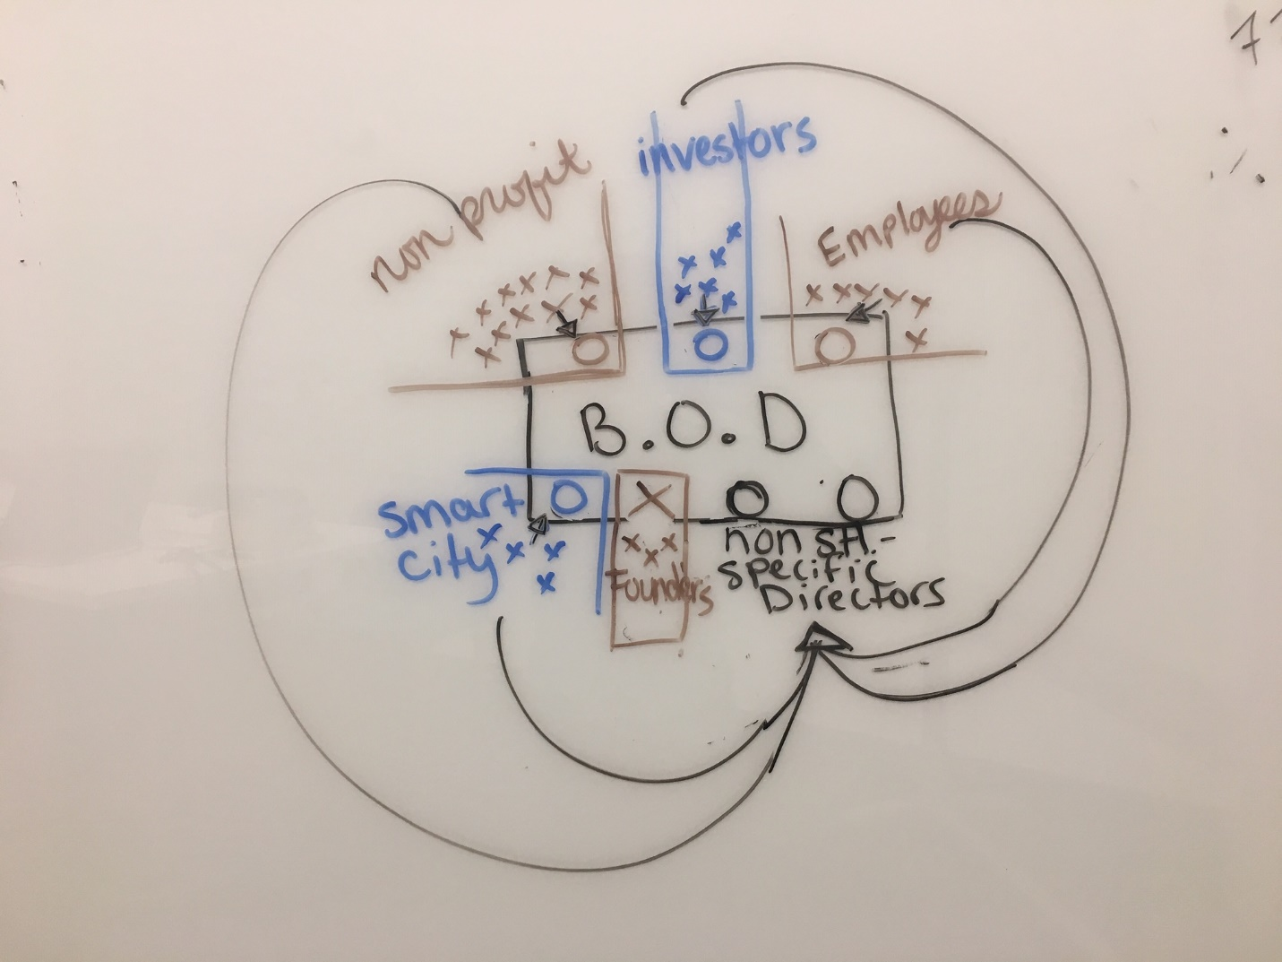

# Private Company:

## Formalized [stock-holding, board-electing and represented] stakeholder groups:

### Employees [trust]

**Purpose:** The purpose of the employee stakeholder group is to give formalized representation to the interests of the employees in company decisions, at the board level and in the workplace. Employee stakeholders will vote for their stakeholder group-specific representatives at the board level, as well as for board-level collaborative partner representatives. Employees will vote directly on choices regarding profit rights-sharing, and other stakeholder group-specific concerns, like budgeting, and day-to-day operations.

**Who is in the group?** The employee stakeholder group will be a group of current (and former?) employees. Employees may also be granted stock (or options, pending an IPO) on an individual basis, but they would be under the “investor” class in that case.

**Trust or individually held?** Stocks will be held in a trust or EDCC (if digital securities -some perks – NV law deters though). They have shared interests such that they could reasonably spend profits on shared resources, such as benefits packages, work perks like food/events/increasing budget on things they wish the company would spend more money on.

### Digital Ethics and Education Nonprofit [trust]

**Purpose:** The purpose of the digital ethics and education stakeholder group is to promote the ethical development and use of technology, in the world and in the DCE. They accomplish this mission through education and outreach efforts and/or lobbying. They elect stakeholder group-specific representatives at the board level, as well as board-level collaborative partner representatives. As a group, they vote directly on profit-sharing distribution/allocation, as well as on decisions concerning organizational mission/purpose (for the nonprofit, not for Blockchains LLC).

**Who is in the group?** The digital ethics and education stakeholder group a multi-stakeholder group unto itself. This group includes individuals working for the nonprofit, the people served by their education/outreach efforts, and Blockchains LLC customers (Vault/ID/etc). Could be an invite-based membership, with automated invitations triggered by predetermined actions by particular players. For example, if you were a Vault user, when you signed up for certain services, they might come with voting rights. This model allows those affected by the technologies we build to have a real voice in what gets built, and in shaping the culture and values of the web 3 space at large and Blockchains LLC in particular.

**Trust or individually held?** Stocks will be held in a trust or EDCC (if digital securities -some perks – NV law deters though). The trust will have limitations that only allow the profits to be spent on certain things (not individually paid-out – must be used to promote the nonprofit’s mission). If the company is not public, then profit right beneficiaries must all fall under securities exemptions, but voting could potentially be done through a legal contract (EDCC?).

### Smart City Residents [Trust]

**Purpose:** The purpose of the Smart City stakeholder group is to give formalized representation to the interests of the people living and working on the land owned by Blockchains at the board level. Smart city stakeholders will vote for their stakeholder group-specific directors at the board level, as well as for board-level collaborative partner representatives. Members of this stakeholder group will manage any profits gained through stock-given profit rights, and will have certain, yet-to-be-determined responsibilities regarding the governance of the land they occupy.

**Who is in this group?** This is dependent on the governance structure of the city, but will probably be open to all individuals and businesses inhabiting the property/land, and will probably be led by some kind of governing body, such as a city council.

**Trust or individually held?** Trust. These people can reasonably be understood to have shared interests and space such that they could govern shared resources for the benefit of the whole.

### Investors (including employees) [individually-held]

**Purpose:** To provide funding to the company and to motivate it to grow the company. They elect stakeholder group-specific representatives at the board level, as well as board-level collaborative partner representatives. As a group, they have no clear need for decisions related to shared resources, and therefore will likely not have their own, internal, governance protocols.

**Who is in this group?** These are accredited investors.

**Individually held stock.**

### Founders [Individually-held]

**Purpose:** The founders are not required to be represented on the board, and have no decision-making power if they choose to stand as board members in an advisory position. However, they may serve to offer continuity in the company’s mission, and important council. They receive profit-rights because they deserve reward, but have no voting rights.

**Who are they?** Jeff, Lee, David.

**Trust or individually-held:** Individual.

## Non stakeholder-specific board members

*Non stakeholder-specific board members act as a potential mediating and common ground-building force. This model also allows for groups whose collaboration with Blockchains is temporary to still have voice, while also limiting the influence of outside parties on the mission and values of our company. They may hold stock, and will be granted stock upon appointment to board, but do not represent the investor stakeholder group.*

### Collaborative Partner Representatives:

**Purpose**: These representatives will serve to represent the interests of the entities with whom we are working on collaborative projects. For example, if we were working with Apple or Microsoft or NV Energy, they could elect to have a board representative. These representatives would be proposed by the collaborative partner, but ultimately accepted or rejected based on shareholder vote to act as a balance of power to ensure that the company mission and culture are maintained.

**Who are they?**: There will be certain provisions around who will qualify for representation on the board, probably based in the length and/or scope of the joint venture. For example, it would only make sense for board representation if the partnership were expected to last for the duration of a director’s term. It is likely that there would also be a provision that allowed for the removal of a director upon the dissolution of a joint venture.

**Collaborative Partners are not a stock holding group** (though it is possible that they own stock in the investor class.)

### Third-Party Common Ground Representatives:

**Purpose**: The purpose of these representatives is to help align the individual stakeholder group’s incentives, as they will be elected by a general election, rather than by individual stakeholder groups.

**Who are they**? There will be pre-designated third-party board positions, which will allow for representation of non stakeholder-specific experts such as industry leaders/execs, or policy advocates/lobbyists/nonprofits. These individuals represent “common ground” between stakeholder groups, and should support the company’s mission and values. These people may provide valuable outside perspectives for consideration.

# Public Company

## Formalized, stock-holding board-electing and represented (or directly acting) stakeholder groups:

### Employees [trust]

*\*\* Regardless of public or private status, the employee stakeholder group remains the same, though their profit and voting rights vary with the addition of new stakeholder groups. For this reason, the text below is the same as under the private company specs.*

**Purpose:** The purpose of the employee stakeholder group is to give formalized representation to the interests of the employees in company decisions, at the board level and in the workplace. Employee stakeholders will vote for their stakeholder group-specific representatives at the board level, as well as for board-level collaborative partner representatives. Employees will vote directly on choices regarding profit rights-sharing, and other stakeholder group-specific concerns, like budgeting, and day-to-day operations.

**Who is in the group?** The employee stakeholder group will be a group of current (and former?) employees. Employees may also be granted stock (or options, pending an IPO) on an individual basis, but they would be under the “investor” class in that case.

**Trust or individually held?** Stocks will be held in a trust or EDCC (if digital securities -some perks – NV law deters though). They have shared interests such that they could reasonably spend profits on shared resources, such as benefits packages, work perks like food/events/increasing budget on things they wish the company would spend more money on.

### Digital Ethics and Education Nonprofit [trust]

*\*The specifics of this stakeholder group varies significantly depending on private or public company status.*

**Purpose:** The purpose of the digital ethics and education stakeholder group is to promote the ethical development and use of technology, in the world and in the DCE. They accomplish this mission through education and outreach efforts and/or lobbying. They elect stakeholder group-specific representatives at the board level, as well as board-level collaborative partner representatives. As a group, they vote directly on profit-sharing distribution/allocation, as well as on decisions concerning organizational mission/purpose (for the nonprofit, not for Blockchains LLC).

**Who is in the group?** The digital ethics and education stakeholder group a multi-stakeholder group unto itself. This group includes individuals working for the nonprofit, the people served by their education/outreach efforts, and Blockchains LLC customers (Vault/ID/etc). Could be an invite-based membership, with automated invitations triggered by predetermined actions by particular players. For example, if you were a Vault user, when you signed up for certain services, they might come with voting rights. This model allows those affected by the technologies we build to have a real voice in what gets built, and in shaping the culture and values of the web 3 space at large and Blockchains LLC in particular.

**Trust or individually held?** Stocks will be held in a trust or EDCC (if digital securities -some perks – NV law deters tho). The trust will have limitations that only allow the profits to be spent on certain things (not individually paid-out – must be used to promote the nonprofit’s mission). If the company is not public, then profit right beneficiaries must all fall under securities exemptions, but voting can be done through a contract.

### Smart City Residents [Trust]

*\*\* Regardless of public or private status, the smart city stakeholder group remains the same, though their profit and voting rights vary with the addition of new stakeholder groups. For this reason, the text below is the same as under the private company specs.*

**Purpose:** The purpose of the Smart City stakeholder group is to give formalized representation to the interests of the people living and working on the land owned by Blockchains at the board level. Smart city stakeholders will vote for their stakeholder group-specific directors at the board level, as well as for board-level collaborative partner representatives. Members of this stakeholder group will manage any profits gained through stock-given profit rights, and will have certain, yet-to-be-determined responsibilities regarding the governance of the land they occupy.

**Who is in this group?** This is dependent on the governance structure of the city, but will probably be open to all individuals and businesses inhabiting the property/land, and will probably be led by some kind of governing body, such as a city council.

**Trust or individually held?** Trust. These people can reasonably be understood to have shared interests and space such that they could govern shared resources for the benefit of the whole.

### BUIDLers [individually-held]

*Couples customers and developers in a natural alliance. This group does not exist under the private model, since many of the individuals in this class would likely not fall under any securities exemptions.*

**Purpose**: to represent the interests of the individuals who contribute to the development of Blockchains’ technology (open source developers, consultant groups) and network (customers) outside of their employment by Blockchains or the nonprofit. They elect stakeholder group-specific representatives at the board level, as well as board-level collaborative partner representatives. Internal governance will be limited due to the lack of shared economic resources, though they are united in the shared interest in Blockchains’ technology, and may organize around their frustrations/hopes regarding that shared interest. There will need to be internal governance protocols for organizing around these concerns, but I anticipate low participation due to lack of economic incentive.

**Who is in this group?**

*Customers* will be give stock options if they meet certain criteria, as specified by each product or service we offer. For example, Vault customers may be offered stock options after some period of holding keys there, or after their account has existed for some period of time, or perhaps based on how much value they deposit there in some amount of time. If we had some identity solution, it might be the case that active IDs would receive stock options after some period, or if it was socially-based, maybe they’d get options once their ID network reached a certain point, etc.

*Open-Source Contributors*, *certain consultant groups, contract employees.* Open source contributors who contribute some predetermined amount of code/time to building Blockchains tech (like a bounty maybe). Perhaps the firms we hire to audit our code, or perform other services on our behalf. Distinct from collaborative partnerships in that BUIDLers are people/entities we hire or who contribute open-source code.

### Investors (including employees) [individually-held]

*\*\* Regardless of public or private status, the investor stakeholder group remains the same, though their profit and voting rights vary with the addition of new stakeholder groups. For this reason, the text below is the same as under the private company specs.*

**Purpose:** To provide funding to the company and to motivate it to grow the company. They elect stakeholder group-specific representatives at the board level, as well as board-level collaborative partner representatives. As a group, they have no clear need for decisions related to shared resources, and therefore will likely not have their own, internal, governance protocols.

**Who is in this group?** These are accredited investors.

**Individually held stock.**

### Founders [Individually-held]

*\*\* Regardless of public or private status, the founder stakeholder group remains the same, though their profit and voting rights vary with the addition of new stakeholder groups. For this reason, the text below is the same as under the private company specs.*

**Purpose:** The founders are not required to be represented on the board, and have no decision-making power if they choose to stand as board members in an advisory position. However, they may serve to offer continuity in the company’s mission, and important council. They receive profit-rights because they deserve reward, but have no voting rights.

**Who are they?** Jeff, Lee, David.

**Trust or individually-held:** Individual.

**Trust or individually-held:** Individual.

## Non stakeholder-specific board members

*Non stakeholder-specific board members act as a potential mediating and common ground-building force. This model also allows for groups whose collaboration with Blockchains is temporary to still have voice, while also limiting the influence of outside parties on the mission and values of our company. They may hold stock, and will be granted stock upon appointment to board, but do not represent the investor stakeholder group.*

### Collaborative Partner Representatives:

*\*\* Regardless of public or private status, this group remains the same.*

**Purpose**: These representatives will serve to represent the interests of the entities with whom we are working on collaborative projects. For example, if we were working with Apple or Microsoft or NV Energy, they could elect to have a board representative. These representatives would be proposed by the collaborative partner, but ultimately accepted or rejected based on shareholder vote to act as a balance of power to ensure that the company mission and culture are maintained.

**Who are they**?: There will be certain provisions around who will qualify for representation on the board, probably based in the length and/or scope of the joint venture. For example, it would only make sense for board representation if the partnership were expected to last for the duration of a director’s term. It is likely that there would also be a provision that allowed for the removal of a director upon the dissolution of a joint venture.

**Collaborative Partners are not a stock holding group** (though it is possible that they own stock in the investor class.)

### Third-Party Common Ground Representatives:

*\*\* Regardless of public or private status, this group remains the same.*

**Purpose**: The purpose of these representatives is to help align the individual stakeholder group’s incentives, as they will be elected by a general election, rather than by individual stakeholder groups.

**Who are they**? There will be pre-designated third-party board positions, which will allow for representation of non stakeholder-specific experts such as industry leaders/execs, or policy advocates/lobbyists/nonprofits. These individuals represent “common ground” between stakeholder groups, and should support the company’s mission and values. These people may provide valuable outside perspectives for consideration.

## Other options:

*You could break up the BUIDLer category into two separate stakeholder groups, but the downside is just that there are a lot of stakeholder groups, which at some point gets a bit unwieldly.*

### BUIDLers [stock options]

**Purpose:** The purpose of this stakeholder group is to give voice and profit-sharing to the individuals who build Blockchains’ technology and network but who are not represented through the employee stakeholder group. They may have a limited internal governance system, but because they will have no shared resources, any such system would necessarily be limited.

*Under the private company model*, BUIDLers will be included in the nonprofit group so that they have access to voting power to elect board members, and so that they can influence outreach and education efforts, but that arrangement does not allow them to benefit financially.

BUIDLers deserve to be included in the success of our company, but require separate representation from employees because they do not necessarily share the same interests of employees, who are likely more interested in the long-term material conditions and benefits offered by the company (when campaigning on the board level and when allocating profit shares).

Another purpose of this group is signaling - to formally recognize this group as valued participants and thereby encourage independent contractors and other contributors to collaborate with us.

**Who is in the group? :** Open-Source Contributors, certain consultant groups, contract employees. Open source contributors who contribute some predetermined amount of code/time to building Blockchains tech (like a bounty maybe). Perhaps the firms we hire to audit our code, or perform other services on our behalf. Distinct from collaborative partnerships in that BUIDLers are people/entities we hire or who contribute open-source code.

BUIDLers deserve to be included in the success of our company, but require separate representation from employees because they do not necessarily share the same interests of employees, who are likely more interested in the long-term material conditions and benefits offered by the company (when campaigning on the board level and when allocating profit shares).

**Trust or individually held:** Because this group does not have any need for shared resources, it would make more sense of these people had individual shares to be offered or granted to them.

### Customers as Cocreators [stock options]:

**Purpose:** This stakeholder group is responsible for representing the interests of customers on the board level. They elect stakeholder group-specific representatives at the board level, as well as board-level collaborative partner representatives. Internal governance will be limited due to the lack of shared economic resources, though they are united in the shared use of Blockchains’ technology, and may organize around their frustrations/hopes regarding that shared interest. There will need to be internal governance protocols for organizing around these concerns, but I anticipate low participation due to lack of economic incentive.

**Who is in this group?** Customers will be give stock options if they meet certain criteria, as specified by each product or service we offer. For example, Vault customers may be offered stock options after some period of holding keys there, or after their account has existed for some period of time, or perhaps based on how much value they deposit there in some amount of time. If we had some identity solution, it might be the case that active IDs would receive stock options after some period, or if it was socially-based, maybe they’d get options once their ID network reached a certain point, etc.

**Individually held or trust?** Individually held.

1. *Alternative option: Possible separation of BUIDLers and customers, or giving customers voting but not profit rights.*